Walk 24 Aconbury Hill
Last walked in Apr 2016

Description. A 6 km (3.7 mile) moderate walk along good woodland paths, roads and across open land. Only a couple of stiles to climb.
Start. Park by Little Birch Village Hall. Explorer Map 189 Grid 506324.
Directions from Belmont Roundabout (Turn milometer to zero). Take the A49 to Ross-on-Wye and after 4 miles, (at the top of the long hill) TL, sign posted King’s Thorn and Little Birch. After 4.7 miles, (just past the 30mph speed limits) TL signposted for Little Birch. Continue along the main road, ignore any turning L or R, to reach the village hall and a red telephone box on your R, total mileage is 5.4 miles.

1. Village Hall. With your back to Little Birch Village Hall, TR and walk past the red telephone box (L). TL at the Methodist chapel (L) and walk up the Public Footpath that behind the chapel. After 120m along a wide track TR thru a kissing gate/gate and walk straight up another wide track into Aconbury wood. Carry straight on up, ignore any turn offs, (you pass two way marker posts on your way up) until you get very near the top, where there is a L and R way-marker post by cross tracks. TR and walk about 150m to the next marker post beneath hill fort ramparts. Aconbury Hill Fort was inhabited from about 200BC to after the Romans arrived, though it seems that it's known locally to be a 'Roman Camp'. The interior of the camp is wooded and a path leads up to its highest point where there is a triangulation point – rather redundant given the density of the trees. When Hereford was under siege during the Civil War, there weren’t many trees on Aconbury Hill and the old Roman fort on the top was in a commanding position. The oval-shaped entrenchments enjoyed unimpeded views over the road coming from Monmouth, across to the Mynde and Much Dewchurch and the approaches to Hereford Castle. In the autumn of 1642, the Royalist forces of Lord Herbert had pushed their way from Raglan Castle via Monmouth on to Aconbury Hill. Thus ensconced, they could reconnoitre a means of recapturing Hereford from the Earl of Stamford’s small Parliamentary army. The roles were reversed in August 1645 when an army of Parliament’s Scottish allies deployed detachments on both Dinedor and Aconbury Hills. Their disciplinary commander, the Earl of Leven, orchestrated the operations of his siege from a tent on the very summit of Aconbury Hill. Immediately past the way marker post you bear R and head off east, to walk along a well defined track, (ignore the track going down hill). The track drops gently down and follows marker posts until you reach the edge of the wood. Near the edge of the wood the track forks L, (on your R hand side you will see a wooden gate and stile).

2. Lower Woodland Edge. Bear L and walk along a broad woodland path, keeping to the L upper path at a fork by a bend, then carry on thru conifers to reach a gravel track in a clearing, at an obvious path junction, by three chopped down tree trunks laying next to each other. From this viewpoint you can see out of the woods and into the walking wild world.

3. Three Tree Trunks. From the view point you continue on the same line but down the lower R grassy track that’s way marked. Follow this waymarked track for 380m to a marker post on your L, then continue on for another 30 paces to find another marker post on your R, and TR down thru a kissing gate into field 1{F1}. Carry straight on down along the L edge of {F1}, (keeping the hedge on your L), to go thru a metal gate and onto Aconbury road.

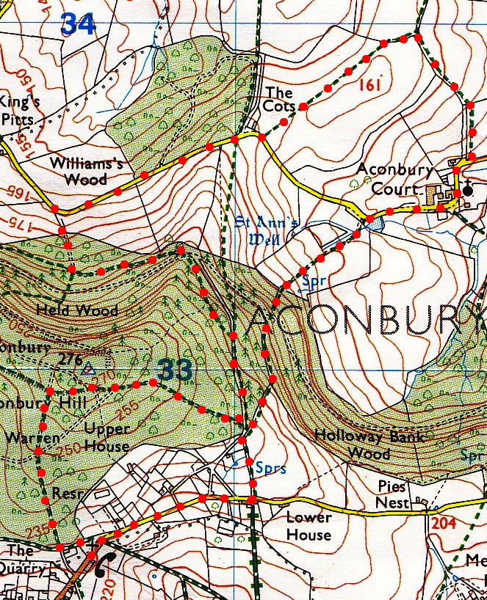
4. Aconbury Road. TR along a quiet lane towards Aconbury. Crest the lane and at a bend in the road just beyond a cottage, climb the L hand bank and go thru a gap in the hedge, which is a Public Footpath, and into {F2}. Head straight across a vast open field, bearing slightly R, to reach a gap in the hedgerow in front that is near to the R hand field corner. Go thru the gap into {F3} and TR. Keep to the hedge on your R and go down hill and into {F4}. Continue down hill and in the same direction, this time with a tree line and ditch on your R, to pass thru a metal gate onto a road.
5
5. Aconbury Church. TR and proceed along the road to Aconbury Church on your L. Saint John the Baptist Church, Aconbury. A Priory for sisters of the Order of St John of Jerusalam and was founded in the reign of King John, and was still recorded as such in 1237, a hospital being attached to it. It probably became an Augustinian monastery soon after this date. The priory church, now the parish church of St John, was built circa 1230-40 and probably extended to the East of the present building. Continue along the bend in the road to pass Aconbury Court, farm buildings and then Aconbury Lodge, to leave the road on the L at the next bend that is just beyond the pond. Go thru the gap and up the field {F5}, keeping L of the tree line. At the end of the tree line the trail goes steeply up hill to an unsigned gap, (direction is roughly 11oclock) and into a wood. You pass an oil drum and continue thru the trees up to a gravel track. TR for 30 paces then sharp L, walk up the bank to where the track starts levelling out and look for the first stile on your R. Cross the stile into {F6} and climb up the R field edge, the woods are on your R, near the top of the field you have to cross over another stile on your R and back into Aconbury Wood. TL and head on down a bridle path to the road at Priory Stone. TR for Little Birch Village Hall.
4
3
2
1

